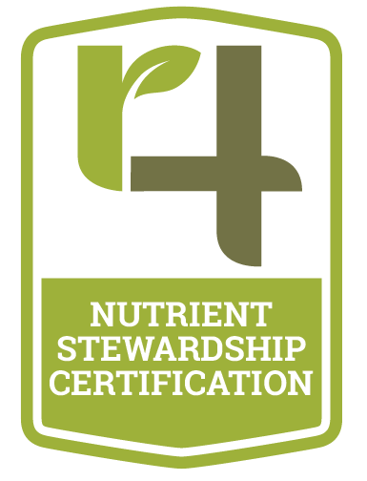

4R Nutrient Stewardship Certification Program in
Ontario

45-day Public Comment Period Report

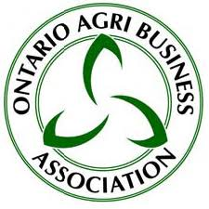
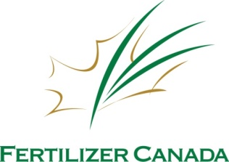
Funding Provided By:

Table of Contents

Introduction……………….……………………………………………..……......3

Goals…………………….…….………………………………………….….……3
Scope………………………………………………………………………..….…4
Structure and Implementation…………………………………………….……..4
Public Comment Period………………………………………………….….…..4
Public Comment Period Q&A………………………………………….…….….5
4R Ontario Certification Webinars………………………………………..……13
Adjustments to the Proposed Certification Standards…………….….……...18

Introduction

The 4R Certification standards were created by the 4R Ontario Steering Committee in close collaboration with the Nutrient Stewardship Council, the Ohio Agri-Business Association and The Fertilizer Institute in the U.S. to ensure alignment between cross-border efforts to implement 4R Nutrient Stewardship and minimize nutrient losses under the 4R Certification Program. The standards are reflective of the best available science, technology and regulatory requirements for Ontario conditions. Members of the 4R Ontario Steering Committee represent a diversity of stakeholders including Fertilizer Canada; the Ontario Ministry of Agriculture, Food and Rural Affairs (OMAFRA); the Ontario Agri Business Association (OABA); the Grain Farmers of Ontario; the Ontario Federation of Agriculture; the Christian Farmers Federation of Ontario; Conservation Ontario; The Nature Conservancy – Ohio; the Ministry of the Environment and Climate Change; the International Plant Nutrition Institute; the Ontario Certified Crop Advisor Board of Ontario; and Ontario agri-retailers.

In implementing this 4R Certification Program, the 4R Ontario Steering Committee sought feedback to ensure a consistent, recognized program for agricultural retailers, agricultural service providers, and certified professionals to help ensure that 4R Nutrient Stewardship goals are adopted and that in turn lead to long term positive impacts on water quality. While these standards do not apply to individual growers, on-farm adoption of the recommendations made by Nutrient Service Providers that become certified under the standards is critical to meeting the goal of improved water quality.

In addition to general principles of 4R Nutrient Stewardship, the standards have incorporated specific criteria for the purpose of addressing regional priorities for water quality, including references to regional soil fertility recommendations and requirements to prevent nutrient application on frozen ground.

The standards are intended to support the adoption of 4R Nutrient Stewardship by specifying best practices for nutrient recommendations and nutrient application. The standards also include an education component to ensure that new practices related to nutrient stewardship are adopted by the Nutrient Service Providers and shared with their grower customers.

The 4R Ontario Steering Committee members will continuously work with the research community to help identify the most effective conservation and nutrient management practices to ensure the standards stay up to date and provide the most current research available.

Goals
The 4R Nutrient Stewardship Certification standards were drafted as part of a voluntary initiative to improve the watershed conditions of the Western Lake Erie Basin. The standards were created to address the following goals:
- optimize crop uptake of nutrients and minimize nutrient losses;
- create long-term positive impacts on water bodies associated with agricultural production areas, including the reduction of eutrophication and incidence of harmful algal blooms, and helping to meet water quality standards;
- encourage sharing of the most up-to-date information about responsible nutrient stewardship with Nutrient Service Providers, growers, and other interested groups; and
- help the agricultural sector adapt to new research and technology in the area of nutrient stewardship.

Scope
The 4R Nutrient Stewardship Program, of which these standards are a central component, is designed to recognize Nutrient Service Providers who have adopted the principles and practices of 4R Nutrient Stewardship. These standards translate 4R Nutrient Stewardship into a set of auditable criteria.

The 4R Nutrient Stewardship Certification Program is voluntary, and applies to Nutrient Service Providers working in the Lake Erie watershed region and all of Ontario, including agricultural retailers, agricultural service provides, and certified professionals. Grower customers of the Nutrient Service Providers are not included under the scope of the standards.

Structure and Implementation
The standards are divided into the following main sections:
- Training and Education
- Recommendations
- Application
- Documentation

Sections 1 and 2 apply to all types of Nutrient Service Providers pursuing certification in the program. Parts of Section 3 may not be applicable for those Nutrient Service Providers that either only make recommendations for nutrient use or only carry out nutrient application.

Each group consists of auditable evaluation criteria, which form the basis of the standards. There are a total of 37 auditable evaluation criteria. Of that total: 6 address training and education, 12 address nutrient recommendations, 10 address nutrient application and 9 address maintenance of proper documentation.

In most cases, a Nutrient Service Provider will offer nutrient recommendations or nutrient application services or both to multiple farms. Unless otherwise specified, 100 per cent of grower customers of the Nutrient Service Provider must meet the requirements specified by the auditable evaluation criteria during every audit year in order to achieve conformance with the standards.

Using the standards as the normative reference, audits will be conducted by third-party auditors to determine whether a specified agricultural retailer, agricultural service provider, or crop adviser, acting as a Nutrient Service Provider, has met the requirements of the standards. The degree of conformance to the standards will be assessed by the auditor, who will evaluate each auditable evaluation criterion, as: Comply, Not Comply, or Not Applicable.

The 4R Certification program will be on a two year audit cycle and is scheduled to be published Spring 2018 and implemented in Fall 2018.

Public Comment Period
Recognizing that the success of the Ontario 4R Certification program and the long-term quality of Lake Erie is of interest to a variety of stakeholders, the 4R Ontario Steering Committee released the proposed standards to the public for a 45-day consultation period.
All comments received were reviewed and incorporated as appropriate. The 4R Ontario Science & Technical Committee and the 4R Ontario Steering Committee made the greatest effort to address concerns and adjust the standards where possible.
We would like to thank all Fertilizer Canada members, stakeholders and Ontario agri-retailers who provided feedback on the Ontario 4R Certification Audit Standards during the 45-day comment period to Feb. 28, 2018. The finalized Standards will require alterations to current practices, and member feedback allowed us to ensure these changes are not only feasible but mutually beneficial to optimizing nutrient availability and reducing nutrient loss.
In order to balance program adoption with credibility, the 4R Ontario Steering Committee has proposed incremental improvement in percent compliance. The proposed compliance increase over the next cycles of implementation is described in the 4R Certification Standards Manual.
Please find below a summary of the feedback received during the 45-day comment period. Collected questions were reviewed and answered by Fertilizer Canada and the Ontario Agri-Business Association on behalf of the 4R Ontario Steering Committee. The public comment period feedback and our response can be found below.

Public Comment Period Q&A:

- What specific training/designation does this person need? Can a CCA with a 4R designation supervise the recommendation of a non-designated person? What might supervise mean? Will a standard CCA certification be adequate or do you see having the 4R endorsement becoming a requirement?
If the staff person is a CCA or Certified Nutrient Management Consultant, then proof of active status is sufficient. If not a CCA, but still a certified professional, print-off of classes taken is needed. If not explicit, include agendas of meetings attended. A signature of Certified Professional for each grower customer is on file, certifying that they approve the nutrient recommendation. Therefore, if a staff is not a CCA, a CCA must approve and sign the form outlining the nutrient recommendation. At this time, it is not a requirement to be a 4R- ON specialty CCA.
- Rarely do growers who won’t pay for soil sampling exceed removal rates, so we believe that this segment should be identified and not included under 4R. “I am going to buy my fertilizer from company X because they don’t make me do all this stuff and sign all these papers.” I can see this coming from some of our customers. We need time to develop a robust electronic record keeping system. Paper is not an option for 4R across 100% of our customer base.
The Certification Process only audits the agri-retailer on what they can control. If a grower is only buying fertilizer, they would not have to sign anything as you are not (as the retailer) making any nutrient recommendations or application. Including and implementing an electronic company policy could be advantageous for collecting grower customer signatures- not only for the Certification program but also for your business.
- Effort has been made in the proposed regulations to take into account practices in Ontario, including accounting for the use of manure in nutrient recommendations- However, overall, the recommendations are primarily focused on managing purchased inputs such as commercial fertilizers.
At this stage of implementation, the 4R Ontario Certification program accounts for manure as a nutrient source but only makes recommendations for purchased inputs such as commercial fertilizer as the audit is for agri-retail facilities and not individual farms.
- Will we be required to show “as-applied” maps for all applications to prove we didn’t spread within the setback areas? If so, we will need time to get there technologically. Not all of our machines are capable today of producing as applied maps. OR/ is a checkbox on the custom app form saying that the “setbacks were observed” adequate?
You will be asked to show that no application occurred within the setback distance. It would be best to create a company policy where grower customers are asked to provide you with known setbacks within their fields. As per the audit beta tests, a company policy/checkbox would be adequate.
- When a grower rents a spreader (or owns a spreader) and buys fertilizer from us, are we required to have him sign-off to say that he didn’t spread within the setback areas for every field he applied? Or is one blanket statement adequate? Some growers have 50+ farms and have their own staff doing the application.
You are only required to collect sign off for recommendations. Application done by the grower customer would be listed under ‘application only’ and therefore, the auditor would not look for further records for recommendation, application, etc done by the agri-retailer.
- Are the setbacks only for phosphorous, or nitrogen and other nutrients as well? Many of the fields we serve see 2-4 nutrient applications per year.
Setbacks are for all nutrient sources.
- Do nutrients that are going through a planter/drill have to abide by the same setbacks?
Yes.
- Do nutrients being applied as a foliar feed, ie Crop Booster, have to abide by the same setback rules?
Yes.
- Do the setbacks apply to manure applications and are we chasing the growers for sign-offs for manure applications?
This program is only auditing the agri-retailer on what is within their control. Therefore, the retailer must document and show that they have considered manure as a nutrient source. However, since the retailer did not apply the manure then they do not have to show that manure applications were followed by the grower.
- R8 – all sources of nutrients are accounted for in the plan. Manure Nitrogen can be unpredictable and many growers are afraid to give it full credit; does the 4R nutrient plan only pertain to phosphorous?
No- the 4R Nutrient Stewardship Ontario Certification program applies to all nutrient sources and agri-retailers must consider all nutrient sources in manure when making a nutrient recommendation or when applying nutrients.
- Can exceptions be made to the 2 years’ worth of nutrients applied in one year rule (found in A4)? Often these sources are used to build soil test levels and a single application can easily exceed what would normally be recommended for 2 years, even in a build scenario.
No, phosphorus application cannot exceed this amount. The 4R Nutrient Stewardship practices and 4R Ontario Certification program incorporate the latest science-based best management practices (BMPs) which account for a build scenario with Ontario soils and have determined that the total application of Phosphorus should not exceed quantity needed for the next two years of planned crops.
- Are we required to recommend stabilizers for applications to winter wheat in the spring? Is a catch all statement placed on the growers crop plan adequate as a recommendation to use nitrogen stabilizers? The decision whether to use it or not still lies with the grower, correct?
Yes, this is correct- you must collect a grower sign off that you discussed the option of nitrogen inhibitors and slow release technologies. Ultimately, it is up to the grower if they implement this technology on their farm or not.
- A2 does not provide a means to apply phosphorous in a No-till situation with current machinery. Very few acres of corn, soys or wheat in Ontario are planted with a significant amount of phosphorous (dry starter) and broadcasting with immediate incorporation or zone tilling negates No-till. There has to be a way to bulk spread Phosphorous in the summer months (low risk months) on the surface and leave it on the surface. This might be the biggest stumbling block/deal breaker for Ontario farmers. If we apply fertilizer with our airflows on wheat stubble in August, September, without incorporation, do we lose our certification? Same question for spring.
Phosphorus injection, subsurface banding, or broadcasting with immediate incorporation are the recommended placement methods unless the risk of phosphorus loss to surface water has been demonstrated to be low according to a provincially approved phosphorus index risk assessment procedure. Therefore, if Phosphorus is bulk spread in low-risk months according to the provincially approved phosphorus index risk assessment procedure, the retail location would not lose certification if this is recorded/ demonstrated.
- Limitations such as the calibration of equipment (as is required in A6) for solid manure should not prevent such farmers from participating as certified acres under the program.
This standard does not prevent farmers from participating. The agri-retailer is the body being audited, and they are being audited only on what they can control. Therefore, a farmer who uses calibration equipment for solid manure can still be a part of the program, as long as they inform their agri-retailer of manure application as a nutrient source prior for additional nutrient applications and as long as the agri-retailer ensures calibration of their equipment for commercial fertilizers.
- A7: Weather at time of application: Is one print-off per day adequate? We run long hours in the spring. Do we need to be looking up the weather forecast and printing it when we dispatch every job? The way A7 is written, the 12 hour clock starts when the machine enters the field.
One print- off per day is adequate to display the forecast/ extreme rainfall. The print off must be from the same source every day.
- A7: is it adequate to have a check box on the custom app form stating that the operator checked the weather (choose a standard app) before starting the job and there was less than a 50% chance of an inch of rain in the next 12 hours?
Yes - having this as a company policy/check off for the applicator at the time of application is sufficient, WITH the daily print-off per day.
- Will we be audited on A8 early-on/future?
A8 states, “Where in-field variability in crop nutrient need or environmental risk is identified and variable rate application is warranted, site specific nutrient application is used.” This standard will be audited within the first year of implementation.
- D1 speaks to the segments of our fertilizer business. How do we account for the customers that buy fertilizer from us that we don’t make recommendations for or do the application for? Eg. Truckload lots of UAN, or they buy some from us and some from other retailers but do their own recommendations.
These customers will not be included in a retailers’ recommendation or application list of grower customers. The retailer is only audited on what they can control, and therefore recommendations are only audited for grower customers on the recommendation list, and the same for application.
- D5: Soil Type: how specific do we need to get with soil types? Where do we find the information?
The Soil Structure on the soil test is sufficient (ie: CC).
- D7: Sign off on recommendations: does the person signing off need to be a CCA? CCA-4R?
Yes, but the staff making the recommendations does not need to be a CCA (see T2 and T3). All recommendations (done by a CCA or non- CCA staff member) must be reviewed and signed off by a CCA.
- D8: Soil Type Delineation: are we required to document different soil types within a given field? Where do we find that information?
In the soil test.
- D9: Watershed: where do we find watershed GIS layers or maps that are specific enough to peg individual farms in each watershed?
The 4R Ontario Steering Committee will work with our Conservation Ontario representative to provide a watershed map as a tool-kit resource made available to agri-retailers and grower customers.
- Nutrient Service Providers participating in this program should be encouraged to offer separate services suitable for these farmers, so that they can also benefit from the training and recommendations of CCAs certified within this program in helping them to manage their nutrient use most effectively on their farms- Limitations such as the calibration of equipment (as is required in A6) for solid manure should not prevent such farmers from participating as certified acres under the program.
This standard does not prevent farmers from participating. The agri-retailer is the body being audited, and they are being audited only on what they can control. Therefore, a farmer who uses calibration equipment for solid manure can still be a part of the program, as long as their inform their agri-retailer of manure application as a nutrient source prior for additional nutrient applications and as long as the agri-retailer ensures calibration of their equipment for commercial fertilizers.
- We genuinely feel that 4R certification should take a phased in approach. In order to receive certification, we must be able to show evidence that we are 4R compliant for 100% of the acres/tasks we control. This would mean that 100% of the acres we make recommendations on would have to have recent soil samples, 100% of the acres we apply nutrients on would have to have maps with sensitive areas and setbacks drawn and observed, among many other tasks and sign-offs that aren’t in place today. The ask here is for a pretty major change in the dynamic between the farm customer and the retailer, and a massive amount of information we don’t have today- a data management system will need to be designed and integrated and we do not believe it is possible to get there immediately. We propose that the requirements be phased in over a 3 year period to give us time to “sell” this to our customers, align our staff and practices, and build software to manage the documentation. We also recognize that 100% compliance will be extremely difficult for any retailer to manage and ask that a change to a graduated system be put in place. Possibly a passing grade allows retailers to keep their certification as opposed to perfection.
Based on feedback from agri-retailers during the public comment period, the 4R Ontario Science & Technology committee and 4R Ontario has worked to include a percent compliance, that that incrementally increases over a set timeline, to allow for uptake of the program and any necessary adjustments.
- There’s nothing too overwhelming in the training section. We will need time to get a CCA certified at every branch. The majority of our Airflow Operators have the Nutrient Applicators license. We propose that this should be sufficient training/proof of understanding for the function they serve in regards to 4R.
The 4R Nutrient Stewardship training will be online eLearning courses, in person Nutrient Management CEU credits or other staff training reviewed and approved by Fertilizer Canada.
- There is nothing under the recommendations standards that shouldn’t already be happening, but unfortunately not all farmers believe in soil/manure sampling, setbacks, and nitrogen stabilizers. To become certified, we can no longer sell fertilizer to farmers that don’t believe in the aforementioned, the way the standards are written today.
These customers will not be included in a retailers’ recommendation or application list of grower customers. The retailer is only audited on what they can control, and therefore recommendations are only audited for grower customers on the recommendation list, and the same for application. Therefore you can sell fertilizer without (unfortunately) the farmer following your recommendations, as long as you are making those recommendations and not applying the fertilizer yourself, you can still sell the customer fertilizer. Again, the retailer is only audited on what they can control.
- There is a fairly major discrepancy between 4R and the general vision of sustainability; generally No-till is touted as being good for the environment and is pushed heavily by OMAFRA, MOE, etc.
No-till is promoted as being good for the environment and has been shown to be a better management practice for soil health. The 4R Ontario Certification Standards are based on the best, province-specific science available. Therefore, although no-till is a good practice for the environment, this specific situation presents other, more pressing issues such as water quality. Incorporating nutrients using conservation or reduced tillage reduces run off of nutrients while being mindful of the harmful effect of conventional tillage.
- Documentation Comments: Some growers are very sensitive about the information we gather and keep on them. The ones that we do a full service business with shouldn’t be a problem, but there are more that fragment their business than those that give us 100%. I’m not sure how we work with those that buy from multiple retailers and keep our certification.
These customers will not be included in a retailers’ recommendation or application list of grower customers. The retailer is only audited on what they can control, and therefore recommendations are only audited for grower customers on the recommendation list, and the same for application. Therefore you can sell fertilizer without the farmer following these practices, as you are only selling fertilizer and not making nutrient recommendations. Again, the retailer is only audited on what they can control.
- It is recommended that it is phased in over a 3 year timeframe and gives retailers leniency on the customers that we cannot get to commit to 4R principles. We want the flexibility to be 4R certified, without losing business, and the ability to choose which growers fit 4R. Perhaps certification could come in the form of a graduated scale, where 80% compliance (or whatever number is deemed appropriate) is a passing grade.
Based on feedback from agri-retailers during the public comment period, the 4R Ontario Science & Technology committee and 4R Ontario has worked to include a percent compliance, that that incrementally increases over a set timeline, to allow for uptake of the program and any necessary adjustments.

As the NMAN software already incorporates many of the items referred to in the phosphorus index, is the index going to be included into NMAN vs another program?
Unaware of any immediate incorporation but would be ideal to include these specific standards within the software.
- Are electronic signatures or an email confirmation suitable as a grower signature or does it need to be an original signature?
Electronic signatures are sufficient.
- Do you know the current legend load in Lake Erie for phosphates and how that will impact future algae blooms?
In 1972, The Great Lakes Water Quality Agreement (GLWQA) set targets for total phosphorus (TP) loads to Lake Erie of 11,000 metric tons annually. Although the phosphorus load is still close to its target today, the dissolved reactive phosphorus (DRP) has increased by 132%. Recently, in 2015, the Objectives and Targets Task Team of Annex 4 of the 2012 GLWQA issued a final report calling for a 40 percent reduction from 2008 loads in spring TP and DRP loading to the Western basin.*(IJC reference)
- What percentage of farmers in south Western Ontario have implemented 4R NMS so far
Approximately 66% (2 out of 3) farmers are practicing 4Rs in Ontario based on 2016 grower survey. This program will help us gain more metrics outlining the uptake of 4Rs specifically in the western basin region compared to all of Ontario.
- Will we be looking at a similar role out to the neonic reg's where certain regions are focussed on to be audited first? Any feel for any different handling for those of us not on the Great Lakes?
This is a voluntary program for agri-retailers and is not a regulation. However, we anticipate that the primary, initial focus will be on the Western Lake Erie Basin (WLEB) region. For agri-retailers not in this area, it is still a beneficial program but would be interesting to have a company policy developed and tested in the WLEB area that could be evolved and easily implemented in other company branch locations.
- Will the certification/audit process be branch specific for retailers with multiple branches across multiple geographies? What should we be targeting as a percentage of compliance across our customer bases?
The 4R Ontario Certification Program will be branch specific. Based on feedback from agri-retailers during the public comment period, the 4R Ontario Science & Technology committee and 4R Ontario has worked to include a percent compliance, that that incrementally increases over a set timeline, to allow for uptake of the program and any necessary adjustments.
- What are the other sources of Phosphorus in the Great Lakes basin? Will municipalities be regulated also?
Agriculture is one contributing source; there are many other sources such as industry, municipalities, etc. To clarify, the 4R Ontario Certification Program is not a regulation, it is a voluntary program to help the agriculture community communicate their commitment to environmental sustainability and the improve water quality of the Great Lakes.
- Do those farmers have crop uptake and crop removal database to determine how best 4R NMS programs working or not?
The 4R Ontario Certification Program is a voluntary program for agri-retailers. The 4R Nutrient Stewardship program is a science-based, proven method for increase nutrient availability and reducing nutrient loss. Fertilizer Canada has a 4R Research Network comprised of 9 leading edge Canadian researchers, demonstration farms and the National 4R Designation Program to help test, quantify and communicate 4R Nutrient Stewardship best management practices (BMPs).
- Would appreciate you letting us know how Conservation Authorities can participate in this program. eg. promotion? training? becoming certified? demonstration sites, etc..
There will be a 4R Ontario Certification Program Toolkit with resources for training, promotion, steps to being certified, 4R demonstration farm locations and results, etc. We are looking to develop and publish this material this spring with the finalized 4R Ontario Certification Standards. In addition, 4R Ontario has hired Warriner Ag as a coach for the program, who will be available to attend and speak on behalf of the program and 4R Ontario. We will include a Conservation Partner specific promotional piece with directions for more information and also promote the program at a variety of events.
- The 4R Program is voluntary for ag retailers, but is it voluntary for the ag retailer's customer's as to whether or not they want to participate in the program (i.e. provide sign-off on documentation, etc.)?
Yes, the program is a voluntary certification program for agri-retailers. The audit only considers what the retailer can control. Therefore, if the retailer recommends 4R practices and obtains a grower sign off on the recommendation, but the grower implements other practices, the retailer has done what is in their control and is compliant according to the standards.
- There was a requirement for application setback from sensitive areas. How are these defined? e.g. "gullies"
Yes, standard R6 specifies a requirement for an application setback from sensitive areas including gullies. The question is whether gullies are defined as a sensitive area. It depends on the severity of the gully. Severe gullies are generally marked on conservation area mapping of sensitive lands, but minor gullies are not.
- How is the 4R certification related to precision agriculture?
Precision agriculture can apply to standard A8 where in-field variability in crop nutrient need or environmental risk is identified and variable rate application is warranted, site specific nutrient application is used. The ability to document practices is essential to pass the audit, using precision agriculture should make it easier to provide the documentation to support the practices used.
- Many CCA's that I talk to about the program suggest that they have been implementing the 4Rs for years. If this is true, it wouldn't seem likely that the program would have an environmental/farm level impact. Do you have any comments on this?
This program aims to provide the necessary information to CCAs not currently implementing 4Rs and provide credit to those CCAs who already are. Although many CCAs are currently implementing some of these practices, the program specifically considers Ontario setbacks and water concerns with relation to Lake Erie and surrounding watersheds.
- More of a suggestion that you not refer to the auditing criteria as 'standards' - this help avoid confusion between voluntary measures with the 4R program and regulation which typically involves 'standards'.
This is a good comment and the committee will be working to commutate effectively that this program is a voluntary audit.
- Is there a long-term plan to implement this province-wide?
Yes. The current implementation of the 4R Ontario Certification Program is Ontario province-wide, with an initial, and priority focus in the Lake Erie western basin. As the program leaves the pilot implementation phase, there will be more focus on other areas in Ontario.
- What was the uptake of 4R certification for retailers in Ohio?
In Ohio, 45 branch retail locations in Ohio have been certified and 37 of those sites are in the Western Lake Erie Basin region. Currently, in Ohio, there is a total of 2.77 million acres under the 4R Certification program.
- The retailer may not be applying manure, but in the future as part of the soil health strategy, they may be involved in helping farmers build organic matter and they may also be involved in “neighbourhood nutrient management planning” (an effort to move manure from an area of high fertility to an area of low to medium fertility levels) where the retailer/consultant would be instrumental in organizing the application using 4R principles such as application after wheat harvest with cover crops etc). If a person adds some organic amendment after wheat harvest to build organic matter and they have a soil test of 15 ppm or higher. They will not be able to apply starter fertilizer to their corn crop. Is this really the message we want to send? Is it really safer to apply 2/3 of the P from manure at the safest time of the year? When does the rest get applied? After harvest on bare and/or frozen soils? And at what GHG cost for the additional imported commercial nitrogen? But there will be retailers with livestock clients that will not want to become 4R certified. Are we going to restrict a person with a 15 ppm soil test to 20 kg/ha or basically just the starter? Are we going to restrict certified retailers to get rid of their livestock customers that are not regulated under nutrient management regulations
Manure is being taken into consideration as a nutrient source. Therefore, it must be included in the nutrient management plan to be audited and certified. However, manure application is not being audited as it is only what the retailer can control. Livestock incorporation will be a priority moving forward for consistent improvement. All standards are based on the most up to date science and address the mentioned concerns

4R Ontario Certification Webinars

During the 45-day comment period, Fertilizer Canada, with members of the 4R Ontario Steering Committee, hosted three audience-specific webinars for Farmers, Agri-retailers and Conservation Partners. These webinars served to further explain the background and structure of the upcoming Certification Program and explain the proposed standards in more detail. The webinars were very successful and analysis concluded that a total of 301 participants (Figure 1) viewed the presentation (65 viewing the Farmer Webinar, 181 viewing the Agri-retailer Webinar and 55 viewing the Conservation Partner webinar).
All three audience specific webinars reported an average increase in their awareness of the 4R Nutrient Stewardship Program post-webinar and, on average, all webinars reported that they consider the 4R Nutrient Stewardship Program important for reducing the negative environmental impacts due to improper fertilizer use (Figures 2-4).
The webinar presentation material and a recording of each webinar were placed on Fertilizer Canada’s website for interested, but unavailable participants and for future reference (https://fertilizercanada.ca/4r-certification-webinars-feb-5-6/).
We would like to thank all Fertilizer Canada members, stakeholders and Ontario agri-retailers who participated in the webinars and provided feedback on the Ontario 4R Certification Audit Standards during the 45-day comment period.

Figure 1: Summary of 4R Ontario Certification webinar participation (clicked link, registered, attended and viewed).

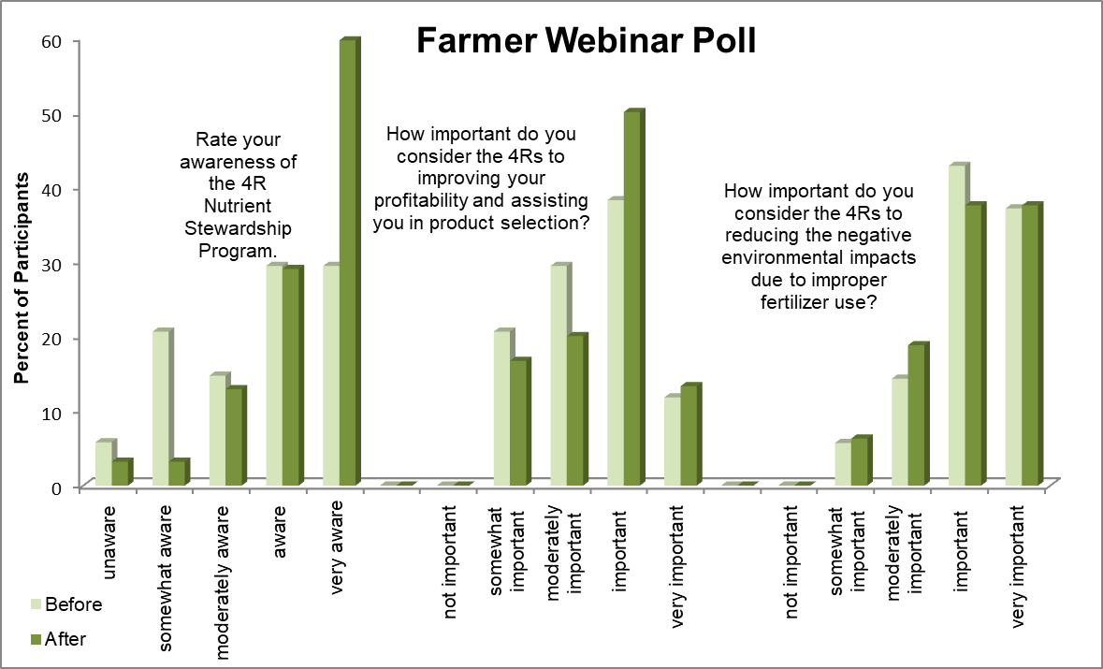
Figure 2: Summary of 4R Ontario Certification Farmer Webinar poll results
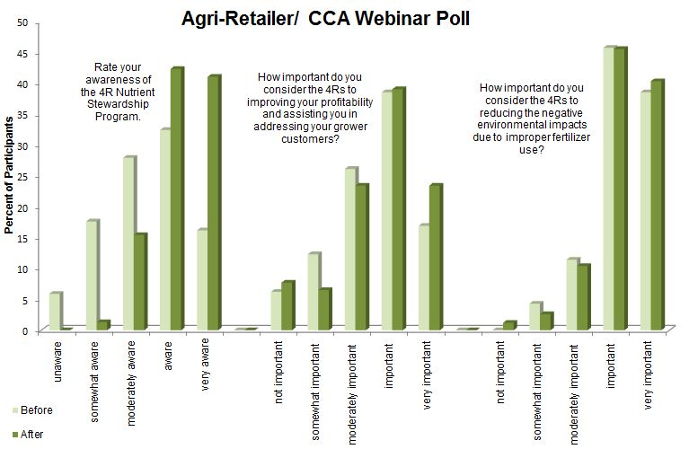
Figure 3: Summary of 4R Ontario Certification Agri-retailer/CCA Webinar poll results

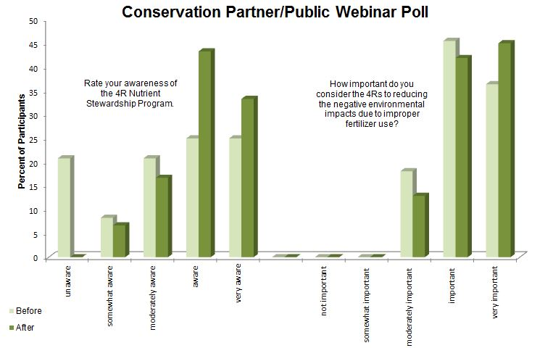
Figure 4: Summary of 4R Ontario Certification Public Conservation Partner/Public Webinar poll results

Adjustments to the Proposed Certification Standards

All comments received were reviewed and incorporated as appropriate. The 4R Ontario Science & Technical Committee and the 4R Ontario Steering Committee is making the greatest effort to address concerns and adjust the standards where possible. Below (Table 1) are the revised standards that were adjusted following the public comment period. Although some of the feedback received may not be included in the below adjustments, there will be further adjustments made to the audited evidence that aims to address identified concerns.
Req. No. | Requirement | Proposed Requirement | Evidence | Proposed Evidence | Percent Compliance | Proposed Compliance  2nd Cycle  2020-2021 | Proposed Compliance  3rd Cycle  2021-2023
T1 | Nutrient Service Providers, sales, and application staff have undergone an initial training and staff are able to demonstrate knowledge about 4R Nutrient Stewardship and the 4R Certification Program. |  | Meeting agendas, education log,or materials indicating 4R concepts and topics (Right Rate, Time, Place and Source) were covered, roster of those in attendance. Can be an interview with various staff. Educational information and sample presentations available at eLearning.fertilizercanada.ca & 4r.fertilizercanada.ca. | All applicable staff have undergone an initial 4R training. Evidence should include: meeting agendas, staff sign-in education log, training materials indicating 4R concepts and topics covered. Staff should be interviewed to answer key 4R concepts (Right Rate, Time, Place & Source). Note: 4R Educational information and sample presentations are available at eLearning.fertilizercanada.ca & 4r.fertilizercanada.ca. | 100% | 100% | 100%
T2 | Certified professionals must have current certification in good standing. |  | Print-off of current credentials and/or certification which include: Certified Crop Adviser (CCA), CCA 4R Specialty or Certified Nutrient Management Consultant. | All certified professionals (CCA, CNMP) on staff should have a copy of current credentials (electronic or hard copy). Evidence should include current credential certificate with full name and certification cycle date(s). | 100% | 100% | 100%
Req. No. | Requirement | Proposed Requirement | Evidence | Proposed Evidence | Percent Compliance | Proposed Compliance  2nd Cycle  2020-2021 | Proposed Compliance  3rd Cycle  2021-2023
T3 | Any staff member making nutrient stewardship recommendations attend training, at least once every 2 years on the practices and principles of 4R Nutrient Stewardship, soil sampling and testing techniques, and/or nutrient water interaction. This is demonstrated through a minimum of 5 hours of documented training per year. | Nutrient Service Provider staff members who are certified professions making nutrient stewardship recommendations must attend 4R training. This is demonstrated through a minimum of 5 hours of documented 4R Nutrient Stewardship training per year. | If the staff person is a CCA or Certified Nutrient Management Consultant, then proof of active status is sufficient. If not a CCA, but still a certified professional, print-off of classes taken is needed. If not explicit, include agendas of meetings attended. | If the staff person is a Certified Crop Advisor then proof of 10 applicable CEU credits is sufficient. Alternatively, for non-CCA staff members training evidence should include: listing of applicable training sessions attended including meeting agendas, training materials covered indicating 4R concepts and verification of attendance. | 100% | 100% | 100%
Req. No. | Requirement | Proposed Requirement | Evidence | Proposed Evidence | Percent Compliance | Proposed Compliance  2nd Cycle  2020-2021 | Proposed Compliance  3rd Cycle  2021-2023
T4 | Nutrient Service Provider's sales and application staff attend two hours of training on 4R Nutrient Stewardship annually. This is demonstrated through relevant training approved by the Ontario 4R Retailer Certification program administrator. | Nutrient Service Provider non-Certified sales and application staff must attend 4R training. This is demonstrated through a minimum of 2 hours of documented 4R Nutrient Stewardship training per year. | Program Administrator must review training offered, it may be through the agri-business itself or through a third-party. Agenda and attendance is required. | All applicable staff has undergone applicable 4R training. Evidence should include listing of applicable training sessions attended including meeting agendas; training materials covered indicating 4R concepts and verification of attendance. | 100% | 100% | 100%
T5 | Nutrient Service Provider has conveyed informational materials on 4R Nutrient Stewardship to all grower customers. | Nutrient Service Provider has conveyed informational materials on 4R Nutrient Stewardship to all grower customers on an annual basis. | Signature by grower, OR proof of attendance at a company sponsored 4R Nutrient Stewardship educational event, OR proof of distribution of materials via mailing list. | Evidence should include: proof of distribution of materials via mailing/email list, meeting description and evidence of 4R information dissemination, or other reasonable forum on an annual basis. | 100% | 100% | 100%
Req. No. | Requirement | Proposed Requirement | Evidence | Proposed Evidence | Percent Compliance | Proposed Compliance  2nd Cycle  2020-2021 | Proposed Compliance  3rd Cycle  2021-2023
T6 | Nutrient Service Provider has sponsored, hosted or directly provided a local training session on 4R Nutrient Stewardship that is available for all grower customers. |  | Agenda of the company-sponsored educational event shows training on 4R Nutrient Stewardship approved by the Program Administrator | Evidence should include: meeting agendas, training materials covered indicating 4R concepts. | 100% | 100% | 100%
R1 | Soil (analysis) tests are conducted by an OMAFRA accredited lab which include, at minimum: organic matter, Phosphorus (Olsen), Potassium, and pH. |  | Review of soil testing records on file, can be hard copy or electronic. All 4 items must be indicated on the records. |  | 100% | 100% | 100%
R2 | Soil tests are conducted at least once every 4 years. |  | Review of records on file, can be hard copy or electronic. Most recent soil test result may not be older than 4 years old. |  | 50% | 100% | 100%
Req. No. | Requirement | Proposed Requirement | Evidence | Proposed Evidence | Percent Compliance | Proposed Compliance  2nd Cycle  2020-2021 | Proposed Compliance  3rd Cycle  2021-2023
R3 | Nutrient recommendations utilize the soil test history of the field, including results from the most recent soil test. |  | Review of records on file, can be hard copy or electronic. Current soil test results must be equal to or less than 4 years old. If it is a new field, crop insurance township averages, drainage, and soil type may be used. |  | 100% | 100% | 100%
R4 | Soil tests are taken at an appropriate depth from relatively uniform areas no larger than 25 acres. |  | Review of records on file, can be hard copy or electronic. Maps indicating acres represented in sample must be provided. All areas sampled must be smaller than 25 acres. | Evidence should include: soil sampling guidance document, applicable staff training. Review soil sampling maps to verify acres sampled are smaller than 25 acres increments | 100% | 100% | 100%
R5 | If manure is applied, its content of total and available nutrients is based on either OMAFRA's database average for the specific manure type, or using sampling and analysis following recognized guidelines. |  | Samples collected using procedures set out in Nutrient Management Act protocols. Analysis must be conducted by OMAFRA approved laboratory. Manure nutrient analysis records (hard copy or electronic) will be reviewed if manure is applied on fields where recommendations are made or fertilizer applied. | Evidence should include: manure sampling guidance document, applicable staff training. Review manure nutrient analysis records (hard copy or electronic), use of OMAFRA or NMA values if no manure sample is taken. | 100% | 100% | 100%
Req. No. | Requirement | Proposed Requirement | Evidence | Proposed Evidence | Percent Compliance | Proposed Compliance  2nd Cycle  2020-2021 | Proposed Compliance  3rd Cycle  2021-2023
R6 | Nutrient recommendations and/or application adhere to minimum setbacks from all known sensitive areas, such as tile inlets, well heads, gullies, and water bodies specified in applicable national, provincial, or local laws. | Nutrient recommendations and/or application appropriately address minimum setbacks from all known sensitive areas, such as tile inlets, well heads, gullies, and water bodies specified in applicable national, provincial, or local laws. | Records of application recommendations and actual applied maps or spreading tickets. Information on (4R Ontario website) will relate to national and provincial regulations. Any local laws will not be updated regularly on the site. | Evidence should include: minimum environmental set back reference document based on federal/provincial requirements, process to ensure local/municipal requirements are documented and adhered to, actual applied maps. Note: Information on (4R Ontario website) will relate to national and provincial regulations. Any local laws will not be updated regularly on the site. | 25% | 50-75% | 100%
Req. No. | Requirement | Proposed Requirement | Evidence | Proposed Evidence | Percent Compliance | Proposed Compliance  2nd Cycle  2020-2021 | Proposed Compliance  3rd Cycle  2021-2023
R7 | For all nutrient recommendations and/or application, the inclusion of a minimum setback distance (e.g., 35-100 ft.) near known sensitive areas, such as tile inlets, well heads, gullies, and water bodies is documented and discussed with the grower customer. |  | Setbacks discussed in meetings with grower customer, in subsequent year’s signatures of grower customers will be on file, or included on customer's application/recommendation cover sheet or maps. | Evidence should include: process to ensure that grower customers are asked to self-identify environmentally sensitive areas on their farms/fields (documented via formal request and receipt of information from grower to retailer). | 25% | 50-75% | 100%
R8 | All sources of nutrients are accounted for in the 4R Nutrient Stewardship Plan, including but not limited to commercial fertilizers, manure/litter, biosolids, cover crops, and the previous crop. |  | Nutrient recommendations indicate all sources of nutrients in the recommendation records. Credits are given to all sources of fertilizer applied and there is a reduction in commercial fertilizer recommended. |  | 100% | 100% | 100%
Req. No. | Requirement | Proposed Requirement | Evidence | Proposed Evidence | Percent Compliance | Proposed Compliance  2nd Cycle  2020-2021 | Proposed Compliance  3rd Cycle  2021-2023
R9 | Crop yield goals are discussed with the grower and are based on previous crop yield history. |  | Review of records on file, can be hard copy or electronic. Proof of level of crop management may be previous yield history, township averages, or local adaptive management research. Discussion about the process and some documentation or records of process. | Evidence should include: process to ensure that grower dialogue involving crop yield goals are documented. Information as part of documentation may include: Review of records on file, previous yield history, township averages, or local adaptive management research. | 50% | 75% | 100%
Req. No. | Requirement | Proposed Requirement | Evidence | Proposed Evidence | Percent Compliance | Proposed Compliance  2nd Cycle  2020-2021 | Proposed Compliance  3rd Cycle  2021-2023
R10 | Recommended nutrient application rates are at or below limits specified by nutrient application recommendations recognized by a government or academic institution that reflects growing conditions consistent with those of the customer. Recommendations may also allow for adaptive management based on documented on-farm data showing reasonable expectation of improved crop yield with a reasonable expectation of no increased risk to water quality by utilizing 4R principles. |  | Records will be compared to credible government or academic sponsored nutrient recommendations first. If above these rates, data from adaptive management research must be presented justifying the different recommendation. Field averages will be used to evaluate these criteria. The Nutrient Management Act is considered a government recognized recommendation source. |  | 100% | 100% | 100%
Req. No. | Requirement | Proposed Requirement | Evidence | Proposed Evidence | Percent Compliance | Proposed Compliance  2nd Cycle  2020-2021 | Proposed Compliance  3rd Cycle  2021-2023
R11 | If urea or UAN is broadcast and not incorporated within 24 hours, it is recommended to be applied with an enhanced efficiency N sources. | If urea or UAN is broadcast on bare ground or is not applied to a growing crop, it must be incorporated within 24 hours. It is recommended to be applied with an enhanced efficiency N sources. | Review of records on file, can be hard copy or electronic. Fertilizer recommendations and applied scale ticket or as-applied map. | Evidence should include: application guidance document, acknowledgement that grower information has been conveyed (i.e. in fertilizer recommendations) and applied maps indicate adherence to policy. | 100% | 100% | 100%
R12 | Discussion on nitrogen management include options of split application, nitrification inhibitors and slow release technologies. |  | producer sign off. | Evidence should include: application guidance documents, acknowledgement that grower information has been conveyed (i.e. fertilizer recommendations) and applied maps indicate adherence to policy. | 100% | 100% | 100%
A1 | Application records shall not exceed recommendations for custom applied acres. Within an acceptable margin of error for calibrated equipment. |  | Review of records on file, can be hard copy or electronic. Nutrient recommendations and applied scale ticket or as-applied map. | Review of records on file, can be hard copy or electronic. Nutrient recommendations and applied scale ticket or as-applied map (5% margin of error). | 50% | 75% | 100%
Req. No. | Requirement | Proposed Requirement | Evidence | Proposed Evidence | Percent Compliance | Proposed Compliance  2nd Cycle  2020-2021 | Proposed Compliance  3rd Cycle  2021-2023
A2 | Phosphorus injection, subsurface banding, or broadcasting with immediate incorporation are the recommended placement methods unless the risk of phosphorus loss to surface water has been demonstrated to be low according to a provincially approved phosphorus index risk assessment procedure. |  | Recommendation records indicate the recommended placement(s). Statement on phosphorus placement given/mailed to grower customers or grower customer signature indicating understanding. | Expectation that language of this requirement will evolve over time with incorporation of the most recent, science-based methods. Evidence should include: application guidance document, acknowledgement that grower information has been conveyed (i.e. fertilizer recommendations). | 100% | 100% | 100%
Req. No. | Requirement | Proposed Requirement | Evidence | Proposed Evidence | Percent Compliance | Proposed Compliance  2nd Cycle  2020-2021 | Proposed Compliance  3rd Cycle  2021-2023
A3 | Crop nutrient applications are neither made nor recommended to be made on frozen or snow covered ground. |  | Recommendation records indicate the preferred timing. Application records indicate there is no frozen ground or snow present. Frozen ground is defined: when soil conditions are such that tillage or nutrient incorporation and/or injection after application are not possible at the time of nutrient application, and will not be possible within the next 48 hours as a result of frozen conditions. Snow-covered ground is defined: when soil cannot be seen because of snow cover. | Evidence should include application guidance document, acknowledgement that grower information has been conveyed (i.e. fertilizer recommendations) and applied maps indicate adherence to document. Note: Frozen ground is defined: when soil conditions are such that tillage or nutrient incorporation and/or injection after application are not possible at the time of nutrient application, and will not be possible within the next 48 hours as a result of frozen conditions. Snow-covered ground is defined: when soil cannot be seen because of snow cover. | 100% | 100% | 100%
Req. No. | Requirement | Proposed Requirement | Evidence | Proposed Evidence | Percent Compliance | Proposed Compliance  2nd Cycle  2020-2021 | Proposed Compliance  3rd Cycle  2021-2023
A4 | Total application of Phosphorus not to exceed the quantity needed for the next two years of planned crops. If a prescribed material is used - must follow the NMA Technical Standard. |  | Records will be compared to a recognized recommendation source. Field averages will be used to evaluate this criteria. Records of individual soil test will be compared to the credible recommendation source or equivalent tool. Crop nutrients regulated under the Nutrient Management Act must follow Technical Standard of the NMA. |  | 75% | 100% | 100%
A5 | Nutrients are applied according to a written nutrient recommendation that has been prepared within the prior three years. |  | Records of application will be compared to the recommendations on file. Only applicable to the full service customers. |  | 100% | 100% | 100%
A6 | All nutrient application equipment must be calibrated, at least annually. |  | Calibration (i.e., maintenance) records indicating equipment service date and any maintenance/service required. | Evidence should include: calibration guidance document, applicable staff training, records indicating equipment service date and any maintenance/service required. To be completed at a minimum annually. | 100% | 100% | 100%
Req. No. | Requirement | Proposed Requirement | Evidence | Proposed Evidence | Percent Compliance | Proposed Compliance  2nd Cycle  2020-2021 | Proposed Compliance  3rd Cycle  2021-2023
A7 | Broadcast applications of crop nutrients without immediate incorporation are neither made nor recommended unless a documented local weather forecast (verifiable private or government generated) indicates less than a 50% chance of a rainfall event involving more than 25mm (one inch) of rain beginning in the next 12 hours. |  | The current weather forecast for the nearest town available to the fields is printed as a record within 12 hours of application. If the chance of precipitation exceeds 50%, the forecast total amount must be less than 25 mm (one inch). A consistent source of weather forecasts is used. | Evidence should include application guidance document, acknowledgement that grower information has been conveyed (i.e. fertilizer recommendations) and applied maps indicate adherence to policy. Note: The current weather forecast for the nearest town available to the fields is printed as a record within 12 hours of application. If the chance of precipitation exceeds 50%, the forecast total amount must be less than 25 mm (one inch). A consistent source of weather forecasts is required. | 100% | 100% | 100%
A8 | Where in-field variability in crop nutrient need or environmental risk is identified and variable rate application is warranted, site specific nutrient application is used. |  | Review of records on file, can be hard copy or electronic. Maps must be provided. Consideration is targeted towards fields that are 25 acres or larger. |  | 50% | 75% | 100%
Req. No. | Requirement | Proposed Requirement | Evidence | Proposed Evidence | Percent Compliance | Proposed Compliance  2nd Cycle  2020-2021 | Proposed Compliance  3rd Cycle  2021-2023
A9 | Records of nutrient application include at minimum:  § method of application;  § time of application;  §field map showing locations of application; nutrient source & rate  §weather (temperature and precipitation) conditions at the time of application; and  weather forecast for the day of application |  | Review of records on file, can be hard copy or electronic. |  | 50% | 75% | 100%
A10 | No application of fall nitrogen other than co-applied with P sources or to meet fall planting N requirements. If a prescribed material is used - must follow the NMA Technical Standard. |  | No application or recommendation for fall application of N other than for what is included in P sources or is used for winter wheat or cover crop. | Evidence should include application guidance document, acknowledgement that grower information has been conveyed (i.e. fertilizer recommendations) and applied maps indicate adherence to policy. Note: No application or recommendation for fall application of N other than for what is included in P sources or is used for winter wheat or cover crop. | 100% | 100% | 100%
Req. No. | Requirement | Proposed Requirement | Evidence | Proposed Evidence | Percent Compliance | Proposed Compliance  2nd Cycle  2020-2021 | Proposed Compliance  3rd Cycle  2021-2023
D1 | Nutrient Service Providers will record a list of grower customers and number of acres in the following categories: full service, recommendation only, application only, and an estimate of all other acres. |  | Review of records on file, can be hard copy or electronic. The NSP will record and submit a list of grower customers and acres per each in the following categories: full service, recommendation only, application only, and an estimate of all other acres. | Evidence should be verified and noted information must be provided to auditor prior to audit. Information to include a list of grower customers and acres per each in the following categories: full service, recommendation only, application only, and an estimate of all other acres. | 100% | 100% | 100%
D2 | Nutrient Service Provider maintains records related to all nutrient and application recommendations by Nutrient Service Provider. |  | Review of records on file, can be hard copy or electronic. Fertilizer recommendations and applied scale ticket or as-applied map. | Evidence should be verified and noted information must be provided to auditor prior to audit. Information to include Review of select records on file such as fertilizer recommendations and applied scale ticket or as-applied map. | 100% | 100% | 100%
D3 | Records related to grower customers are kept confidential by the Nutrient Service Provider and are made available for review during an audit. |  | Confidentiality statement with NSP and auditor signatures. Records are kept confidential by NSP as demonstrated with computer codes, file cabinets, or "safe" rooms or confidentiality agreement with the grower customer. | Evidence should include: Confidentiality statement with NSP and grower customers. Auditor agreement between auditor and NSP. Records are kept confidential by NSP as demonstrated with computer codes, file cabinets, or "safe" rooms or confidentiality agreement with the grower customer. | 50% | 75% | 100%
Req. No. | Requirement | Proposed Requirement | Evidence | Proposed Evidence | Percent Compliance | Proposed Compliance  2nd Cycle  2020-2021 | Proposed Compliance  3rd Cycle  2021-2023
D4 | Nutrient Service Provider keeps onsite list and/or copies (either electronic or hard-copy) of relevant national, provincial, or municipal laws related to nutrient recommendations and application. |  | Review of records on file, can be hard copy or electronic. | Evidence should include: listing of applicable federal/provincial regulatory requirements, process to ensure local/municipal requirements are documented and adhered to. Note: Information on (4R Ontario website) will relate to national and provincial regulations. Any local laws will not be updated regularly on the site. | 100% | 100% | 100%
D5 | Records of individual fields that are accesible to the retailer and made available to the grower/customer include, at minimum:  § field boundary, soil type  § current soil test results, nutrient recommendations§ crop yield goals used for making recommendations, and rates applied to each field |  | Review of records on file, can be hard copy or electronic. | Evidence should include guidance documents, acknowledgement that grower information has been conveyed. Review of records on file, can be hard copy or electronic. | 50% | 75% | 100%
Req. No. | Requirement | Proposed Requirement | Evidence | Proposed Evidence | Percent Compliance | Proposed Compliance  2nd Cycle  2020-2021 | Proposed Compliance  3rd Cycle  2021-2023
D6 | Nutrient recommendations have been reviewed and acknowledged in writing by the grower/customer. |  | Signatures of grower customers on file. | Evidence should include: nutrient recommendation acknowledgement that grower information has been conveyed (i.e. fertilizer recommendations). Signatures of grower customers on file. | 50% | 75% | 100%
D7 | Nutrient recommendations for each grower have been approved and signed by a Certified Professional. |  | Signatures of Certified Professional for each grower customer is on file, certifying that they approve the nutrient recommendation. |  | 50% | 75% | 100%
D8 | 4R Nutrient Plans must include information about yield goals, known sensitive areas (e.g., surface water, inlets, wells, etc.), soil type delineation, setbacks, and soil test results. |  | Review of records on file, can be hard copy or electronic. There may be multiple field maps to ensure all the information is outlined. |  | 50% | 75% | 100%
D9 | Field records related to monitoring of 4R implementation must include the watershed where the farms are located. |  | Identify by watershed name or supply GIS data layer and/or hard copy map. |  | 50% | 75% | 100%

