
Example Tweets by Morgan Laforge

(Section 1 YouTube videos)
Growing Stronger: Safety and Security at the Forefront -https://www.youtube.com/watch?v=Q1ScEGT2p-I&feature=youtu.be
Current Views: 8,260 current views

- Without fertilizer food production could be cut in half, that is why we have created guidelines and work closely with farmers to ensure proper fertilizer storage practices. #Growingstronger

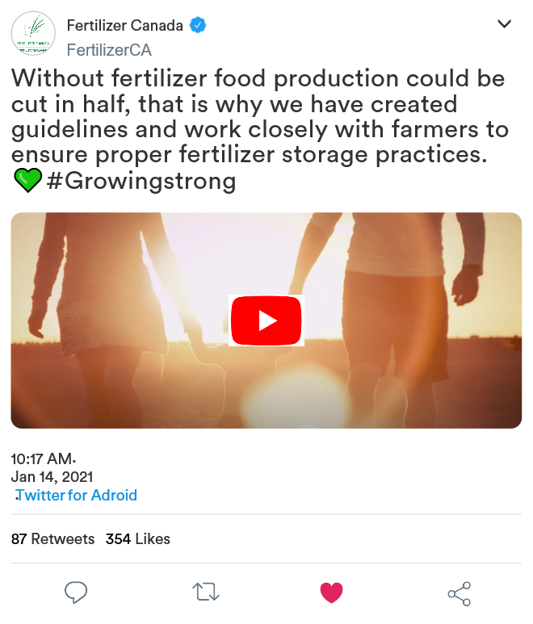
Date posted: March 14, 2016
Views as of February 10, 2021(1 week after posting): 10,260
Views gained: 2,000 views gained
A Stronger Recovery with Canadian Fertilizer https://www.youtube.com/watch?v=3ZeTKbLsfPI&feature=youtu.be
Current Views: 120
Here at Fertilizer Canada, we recognize these have been trying times for everyone. While much of the world stays home, Canadas fertilizer industry keeps working. The world depends on fertilizer for food security, you can count on us. #foodsecurity #fertilizer #COVID_19 #sustainibility


Date posted: February 3, 2021

Views as of February 10, 2021 (1 week after posting): 750
Views gained: 630

Fertilizer Canada - Safety in the Supply Chain https://www.youtube.com/watch?v=gOZVVxPfSpE&feature=youtu.be
Current Views: 56
- Did you know Canadas agriculture sector generates $49 billion for the Canadian economy each year? Here at Fertilizer Canada, we like to take an active management approach to ensuring fertilizer safety and security practices. For more information take one of our eLearning courses today in the link provided below. www.fertilizercanada.ca


Date posted: February 3, 2021
Views as of February 10, 2021(1 week after posting): 356
Views gained: 300

4R Nutrient Stewardship: Morgan's 4R Experience- https://www.youtube.com/watch?v=Fgti5vXzJcQ&feature=youtu.be

Current Views: 132
The 4R Stewardship program helps farmers like Morgan increase their farmlands environmental sustainability for future generations to come. For more information on how to get involved with this program visit our website at www.fertilizercanada.ca

Date posted: February 10, 2017
Views as of February 10, 2021(1 week after posting): 650
Views gained: 518

(Section 2 other written materials)

**Mock Twitter survey** Economic report
- If you had to guess, how much revenue do you think the agriculture sector generates annually for the Canadian economy?

a) $49 billion
b) $256 million
c) $13 billion
** The right answer would light up green or show a check mark beside it on a real Twitter survey**

Annual report 2020 – Did you know all plants require Nitrogen to grow? Thankfully, Fertilizer Canada provides industry-leading stewardship to ensure the safety, security and sustainability of these nitrogen-based fertilizers across the country.

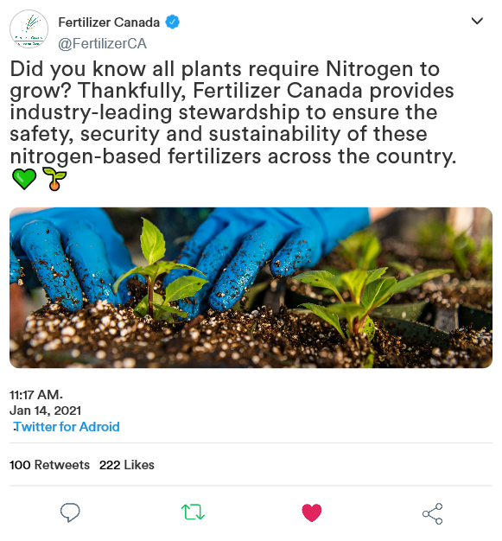

Stewardship report - Soil sampling is helping Canadian growers! By implementing this practice every three years, growers and crop advisors are able to determine what their crops need, as well as help protect the eco-system.
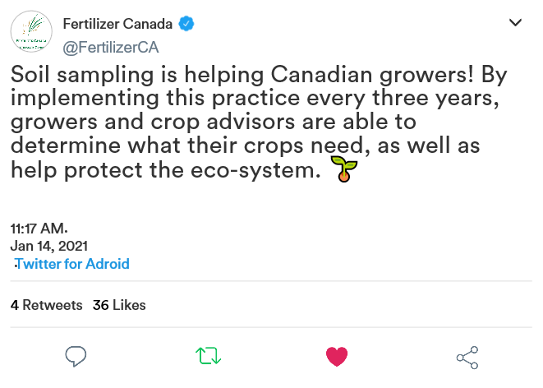

Website I used to make fake Tweets
https://zeoob.com/generate-twitter-tweet/

